Gene Recognition via Spliced Sequence Alignment
Mikhail S. Gelfand, Andrey A. Mironov, and Pavel A. Pevzner
Genetics, Vol. 93, pp.9061-9066, August 1996
- Introduction
In this paper, we propose a new combinatorial approach to the exon assembly problem, which uses related proteins to derive the correct exon-intron structure.
- Spliced Alignment Problem

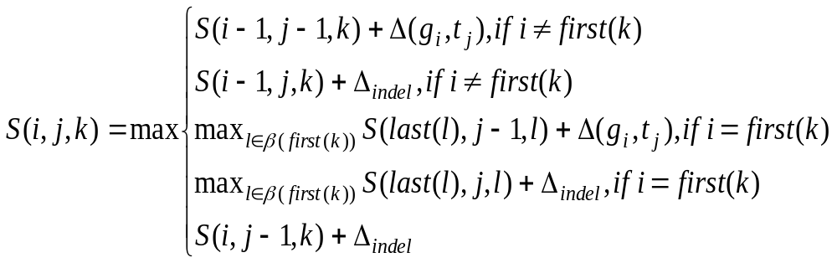
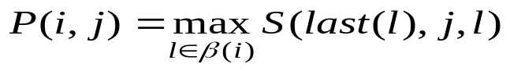
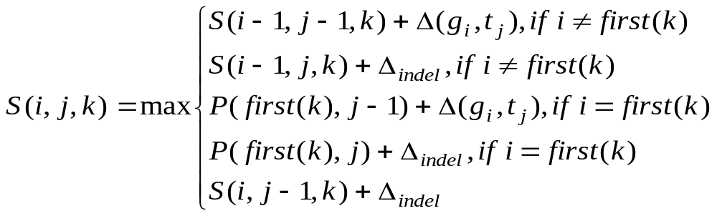

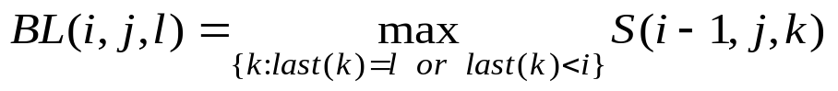
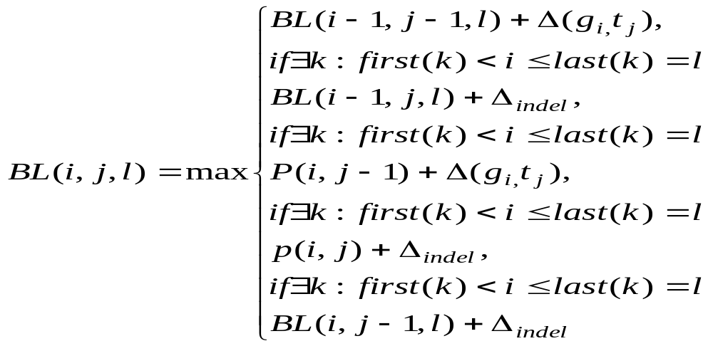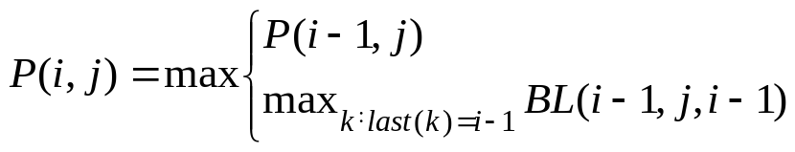
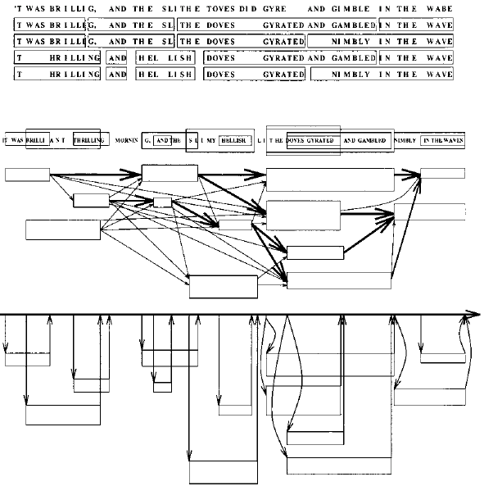
Created by : Jih-Wei Huang
Date : Sept. 12, 2002

